Smarter Home Automation Project Document

1. Overall Design

Smarter Home Application is aiming to build a comfortable and peaceful environment for people when they are at home. Mainly function including sign in and sign up, weather display, control and detecting lights status, provide sound level justifying and review the sound historic records.

2. Design Decision

Considering the application is allowing all users to download and install, the application will require an online database instead of a local storage. Thus, the Firebase is implemented to store user’s information such as user’s portrait, name and records.

In general, there is no one want anyone else to use this application to control their own smart home devices, so the sign in and sign up function is required. But due to the limitation of the hardware we are using, it is difficult for us the add the pair light function. So, the assumption will be there are devices already paired in advance and after user logged in, they can control their own lights.

The raspberry pi will be responsible for controlling the lights through the mobile switch or the motion sensor. The temperature will be recorded from the I2C barometer.

The left major issue is the sound sensor at first we planned, is not supporting analog signals. In order to fetch the analog number, Arduino has to be used. After the Arduino fetch the data, it will be transferred by USB Serial to the raspberry pi and then pi will handle the upload to the firebase.

3. Overall Architecture

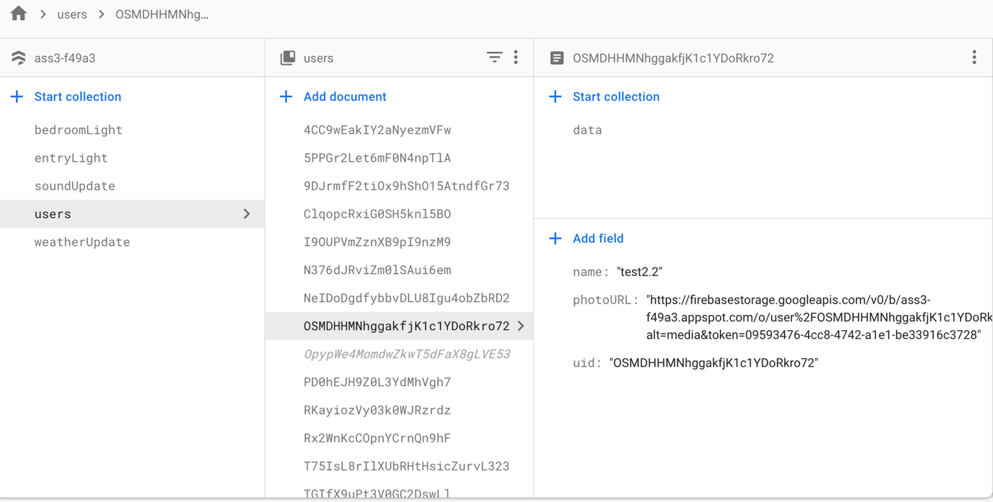

This is the online architecture of the firebase cloud firestore. Under different users, there will be more collections about the sound record and suggestions. With more data comes into the collection, more documents will be added.

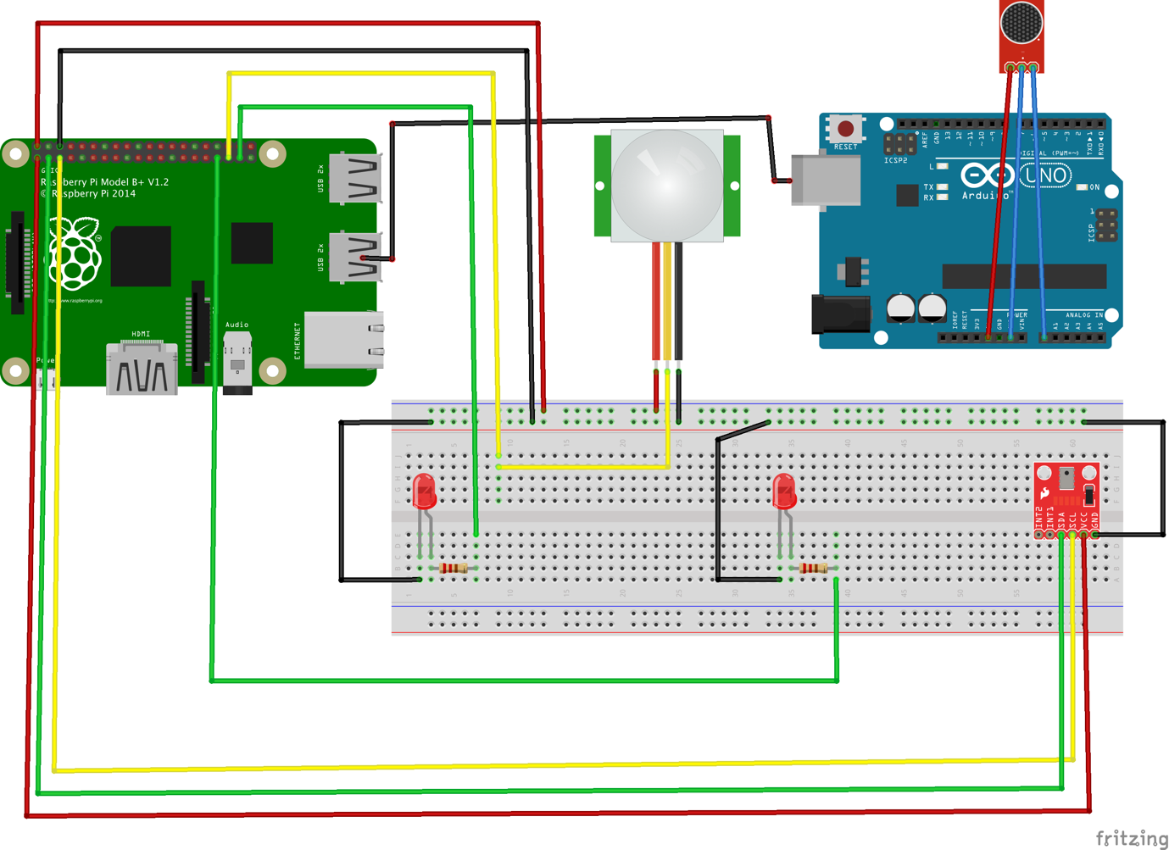

This is the overall architecture of the project. Arduino and the raspberry is connected using USB wire to transfer the data (Cannot find the right line, using the jumping wires instead).

4. Used libraries and other material

On the web server side, we using python and its libraries including GPIO, Serial and Firebase and etc. Using GPIO is to control the input and output of the power. The serial library is to collect the data read from Arduino.

In IOS section we use Firebase including firebase Authentication, Storage and Database to correctly fetch and read data from the storage.